Final Report: Grain Palette - A Deep
Learning Odyssey in Rice Type Classification
Team Member Name: MALAPATI LAVANYA
Date : 2/07/2025
Team ID : LTVIP2025TMID46091

1. INTRODUCTION

1.1 Project Overview
Grain Palette is a deep learning-based web application designed to classify five different varieties of rice using transfer learning with MobileNetV2. This tool aims to assist farmers in identifying rice types accurately without requiring expensive agricultural expert consultations.

1.2 Purpose
The primary objective of this project is to provide an affordable and efficient solution for rice classification. By leveraging machine learning, farmers can make informed decisions about rice quality and market value.
1.3 Data Collection
Collect rice grain images from a dataset (e.g., Kaggle – Rice Image Dataset)
Organize images into folders based on rice type (e.g., Basmati, Jasmine, Arborio, etc.)
Split into train, validation, and test sets (e.g., 70/20/10)

2. IDEATION PHASE

2.1 Problem Statement
Rice classification is traditionally performed by agricultural experts, making it costly and inaccessible to many farmers. An automated system can bridge this gap by offering an instant and reliable classification tool.

2.2 Empathy Map Canvas
Understanding the needs, challenges, and perspectives of farmers to develop a user-friendly solution.

2.3 Brainstorming
Identifying potential machine learning models, dataset sources, and application features to maximize usability and accuracy.

3. REQUIREMENT ANALYSIS

3.1 Customer Journey Map
Mapping out the user interaction with the web application, from image upload to rice variety prediction.

3.2 Solution Requirement
- Image-based classification of rice varieties.
- Web interface using Flask.
- Lightweight deep learning model (MobileNetV2) for fast predictions. 3.3 Data Flow Diagram
Illustrating the process flow from image input to rice variety prediction output.
3.3 Goal:
To build a machine learning model that can accurately classify different rice grain types using image data. The model is developed using transfer learning (e.g., MobileNet, VGG16), which helps reduce training time while achieving high performance with limited data.

3.4 Technology Stack
- Frontend: HTML, CSS, JavaScript
- Backend: Flask (Python)
- Model: MobileNetV2 (TensorFlow/Keras)
- Database: SQLite (if applicable)

4. PROJECT DESIGN

4.1 Problem Solution Fit
Ensuring the model accurately classifies rice types and is accessible to farmers via a simple web interface.

4.2 Proposed Solution
Implementing a Flask-based web app that allows users to upload rice grain images and receive instant classification results.
4.3 Solution Architecture
High-level architecture diagram detailing model training, web hosting, and user interaction.
4.4 Application Building
Build a Streamlit or Flask web app
Allow users to upload rice grain images
Load the saved model and make predictions
Display the predicted rice type with confidence score
Grain Palette Diagram
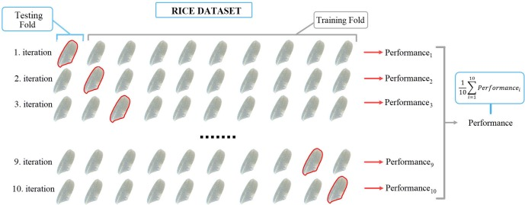
Image generators Code :
import numpy as np
import tensorflow as tf
from tensorflow.keras import layers, models
import matplotlib.pyplot as plt
# Simulated dataset parameters
# Define the parameters for the simulated dataset
NUM_CLASSES = 5 # Example: 5 types of rice
IMG_HEIGHT = 128
IMG_WIDTH = 128
NUM_SAMPLES = 1000 # Number of training samples
BATCH_SIZE = 32 # Define BATCH_SIZE here
num_classes = NUM_CLASSES # e.g., Basmati, Jasmine, Arborio, Brown, White
img_height, img_width = IMG_HEIGHT, IMG_WIDTH
num_train = NUM_SAMPLES
num_val = 100
# Generate random synthetic image data and labels
X_train = np.random.rand(num_train, img_height, img_width, 3)
y_train = tf.keras.utils.to_categorical(np.random.randint(0, num_classes, size=(num_train,)), num_classes)

X_val = np.random.rand(num_val, img_height, img_width, 3)
y_val = tf.keras.utils.to_categorical(np.random.randint(0, num_classes, size=(num_val,)), num_classes)
# Build the CNN model
model = models.Sequential([
layers.Input(shape=(img_height, img_width, 3)),
layers.Conv2D(32, (3, 3), activation='relu'),
layers.MaxPooling2D(),
layers.Conv2D(64, (3, 3), activation='relu'),
layers.MaxPooling2D(),
layers.Conv2D(128, (3, 3), activation='relu'),
layers.MaxPooling2D(),
layers.Flatten(),
layers.Dense(128, activation='relu'),
layers.Dropout(0.5),
layers.Dense(num_classes, activation='softmax')
])
# Compile the model
model.compile(optimizer='adam',
loss='categorical_crossentropy',
metrics=['accuracy'])
# Train the model
history = model.fit(X_train, y_train, validation_data=(X_val, y_val), epochs=5, batch_size=BATCH_SIZE)

# Plot training & validation accuracy
plt.plot(history.history['accuracy'], label='Train Accuracy')
plt.plot(history.history['val_accuracy'], label='Validation Accuracy')
plt.title('Rice Type Classification (Simulated)')
plt.xlabel('Epoch')
plt.ylabel('Accuracy')
plt.legend()
plt.show()

5. PROJECT PLANNING & SCHEDULING

5.1 Project Planning
Timeline and milestones for dataset collection, model training, web development, and deployment.

6. FUNCTIONAL AND PERFORMANCE TESTING
6.1 Performance Testing
Evaluating the model's accuracy, speed, and efficiency in classifying rice varieties.

7. RESULTS

7.1 Output Screenshots
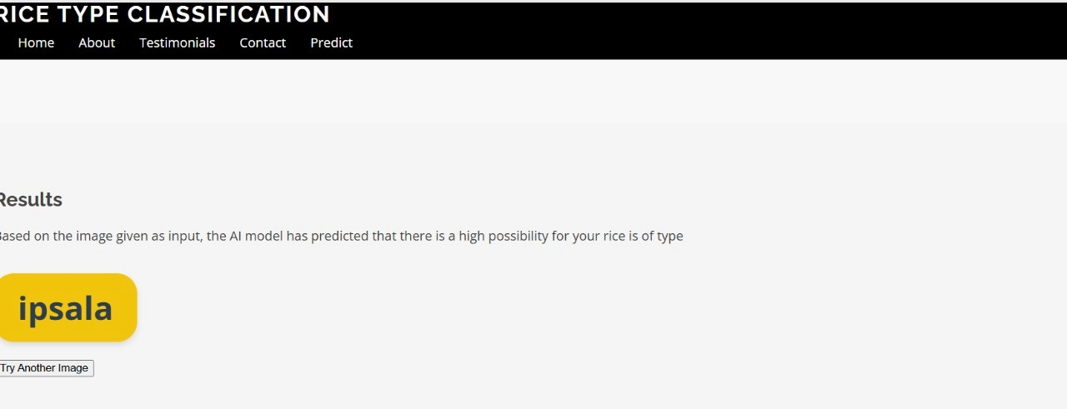
Displaying the web app interface, classification results, and model performance.

8. ADVANTAGES & DISADVANTAGES
- Advantages: Affordable, accessible, and user-friendly rice classification.
- Disadvantages: Accuracy dependent on dataset quality, requires internet access.
9. CONCLUSION
Summarizing project achievements, challenges, and potential improvements.

10. FUTURE SCOPE
Enhancements such as integrating more rice varieties, improving model accuracy, and developing a mobile app version.
Expected Output:
A trained model capable of classifying rice grain types with good accuracy.
A deployable app for rice grain prediction.
Visualizations of training curves and model architecture.
GitHub repo with all project code, images, and documentation.

11. APPENDIX

Dataset Link: Rice Image Dataset
- Project Demo Link:
https://drive.google.com/file/d/1-MzKiaU0SYV47o3sPe1_Zph7R8CUvvf_/view?usp=drivesdk
Thank You!
Project guided and supported by SmartBridge.

